Personal Profile
Mrs.N.Shailaja
M.Sc(Mathematic), B.Ed, SET
Degree Lecturer
Department of Mathematics
TTWRDC(W) Rajanna Siricilla-505405
Telangana State, India.
Email: shailajareddygudipati@gmail.com

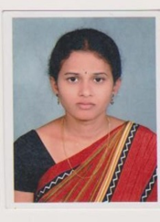

Basic Data
Father’s Name  Mobile | : Vijender Reddy  : 9493431411
Mother’s Name  Total Experience | : Radha  : 8 years
D O B  DOJ | : 26th February1984  : 29th August 2019
Caste | : OC
Religion | : Hindu
Nationality | : Indian

EDUCATIONAL QUALIFICATIONS
- Master of Science in Mathematics from Osmania University.
- Bachelor of Education from Osmania University.
- Bachelor of Science in Computer Science from Kakatiya University.

QUALIFICATIONS OF ELIGIBILITY TESTS
Sl. No | Qualification | Conducted by | Appeared on | Date of Qualifying
1 | SET(Mathematics) | Osmania University, Hyd. | 27th July, 2012 | 15th November, 2012

SERVICE PARTICULARS:
Sl. No | Designation | Name of the College | Working Period |  | Length of Service | Remarks
 |  |  | From | To
1 | Asst.Proffessor | Vignan Institute of Technology & Science | November2008 | May 2013 | 5 years
2 | Degree Lecturer | TTWRDC(W); Rajanna Siricilla | 29th August 2019 | Till | 4 years

TRAINING COURSES ATTENDED:
Sl. No | Title of the Course Attended | Organized By | Date | Remarks
1 | Workshop on Introduction to Research methodologies | Indian Institute of Technology, Bombay | 25th June to 4th July2012
2 | One day work shop on Applications of Mathematics in Engineering Science & Mind set for Mathematical models | KrishnaMurthy Institute of Technology & Enginering | 6th august 2011

******

Personal Profile
Mrs.S. Anusha
M.Sc(Mathematic), B.Ed,
Guest Degree Lecturer
Department of Mathematics
TTWRDC(W) Rajanna Siricilla-505405
Telangana State, India.
Email: sriram.anu31@gmail.com

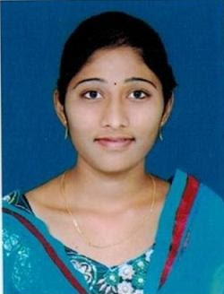
Basic Data
Father’s Name  Mobile | : Sriram Punnaiah  : 9676736784
Mother’s Name  Total Experience | : Rani  : 7 years
D O B  DOJ | : 7th February 1992  : 21st september 2019
Caste | : BC-B
Religion | : Hindu
Nationality | : Indian

EDUCATIONAL QUALIFICATIONS
- Master of Science in Mathematics from Sathavahana University.
- Bachelor of Education from Sathavahana University.
- Bachelor of Science in Computer Science from Sathavahana University.

SERVICE PARTICULARS:
Sl. No | Designation | Name of the College | Working Period |  | Length of Service | Remarks
 |  |  | From | To
1 | Lecturer | Sreechaithanya Degree & PG College | July2016 | June2019 | 3 years
2 | Guest Degree Lecturer | TTWRDC(W); Rajanna Siricilla | 21st September 2019 | Till | 4 years

